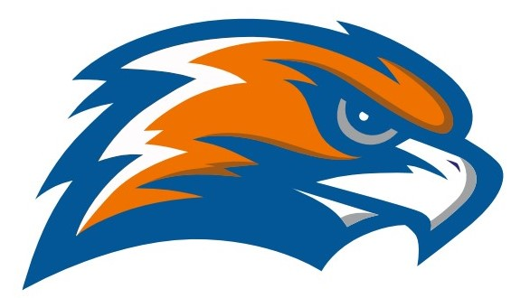

| **GARRETT MORGAN MEN’S BASKETBALL Senate - Erie Division 2021-2022** |
| --- |

Head Coach Kevin Aufmuth Assistant Coach Robert Morse III

Principal GMSEI Quenton Davis Principal GMSLI Anshawn Ivery

Athletic Director Jennifer Smith Cheer Advisor Angela Toney

| **DATE** | **TIME** | **VISITOR** | **HOME** | **SITE** |
| --- | --- | --- | --- | --- |
| **Tuesday**  **11/30** | **5:30 JV**  **7:00 V** | **Collinwood** | **Garrett Morgan** | **Garrett Morgan** |
| **Friday**  **12/3** | **5:30 JV**  **7:00 V** | **Garrett Morgan** | **Max Hayes** | **Max Hayes** |
| **Monday**  **12/6** | **7:00 V** | **Garrett Morgan** | **Bard** | **Bard** |
| **Friday**  **12/10** | **5:30 JV**  **7:00 V** | **Garrett Morgan** | **Campus International** | **Wilson** |
| **Monday**  **12/13** | **5:30 JV**  **7:00 V** | **Lincoln West** | **Garrett Morgan** | **Garrett Morgan** |
| **Friday**  **12/17** | **5:30 JV**  **7:00 V** | **John Hay**  **(independent)** | **Garrett Morgan** | **Garrett Morgan** |
| **Tuesday**  **12/21** | **5:30 JV**  **7:00 V** | **Hawken** | **Garrett Morgan** | **Garrett Morgan** |
| **Tuesday**  **12/28** | **5:30 JV**  **7:00 V** | **Garrett Morgan** | **Brooklyn** | **Brooklyn** |
| **Friday**  **1/7** | **5:30 JV**  **7:00 V** | **Garrett Morgan** | **Collinwood** | **Collinwood** |
| **Tuesday**  **1/11** | **5:30 JV**  **7:00 V** | **Max Hayes** | **Garrett Morgan** | **Garrett Morgan** |
| **Friday**  **1/14** | **7:00 V** | **Bard** | **Garrett Morgan** | **Garrett Morgan** |
| **Tuesday**  **1/18** | **5:30 JV**  **7:00 V** | **Campus International** | **Garrett Morgan** | **Garrett Morgan** |
| **Friday**  **1/21** | **5:30 JV**  **7:00 V** | **Garrett Morgan** | **Lincoln West** | **Lincoln West** |

**ERIE DIVISION SENATE CHAMPIONSHIP GAME**

**Tuesday February 8 @ 7:30**

**Rocket Mortgage Field House**

**OHSAA SECTIONALS - February 14 - 26 TBA**

**Senate Athletic League - Erie Division**

**Bard Campus International Collinwood Garrett Morgan Lincoln West Max Hayes**